a. Write a program to generate different series.

**1, 2, 3, 4, 5, ……10th**

Cls

For i = 1 To 10

Print i;

Next i

End

**1, 3, 5, 7, ………10th**

Cls

For i = 1 To 10 Step 2

Print i;

Next i

End

**1, 4, 9, 16, 25, 36, … 10th**

Cls

For i = 1 To 10

Print i ^ 2;

Next i

End

**2, 8, 18, 32, …. 10th**

Cls

For i = 1 To 10

Print 2 * i ^ 2;

Next i

End

**1, 2, 4, 7, …. 10th**

Cls

s = 1

For i = 1 To 10

Print s;

s = s + i

Next i

End

**5, 10, 20, 35, … 10th**

Cls

s = 5

For i = 5 To 100 Step 5

Print s;

s = s + i

Next i

End

**1, 5, 9, 13, 17, ….10th**

Cls

For i = 1 To 100 Step 4

Print i;

Next i

End

**1, 1, 2, 3, 5, 8, … 10th (Fibonacci)**

Cls

a = 1

b = 1

Print a;

Print b;

For i = 1 To 10

c = a + b

Print c

a = b

b = c

Next i

End

**b. Write a program to calculate sum of n-natural number.**

Cls

s = 0

For i = 1 To 100

s = s + i

Next i

Print s

End

**c. Write a program to calculate product of n-natural number. (factorial of a given number)**

Cls

s = 1

For i = 1 To 100

s = s * i

Next i

Print s

End

d. Write a program to calculate sum of digits of a given number. Eg: 111 sum of 1+1+1 is 3

**Logic: r = n Mod 10**

**s = s + r**

**n = n \ 10**

e. Write a program to calculate product of digits of a given number.

f. Write a program to reverse a given number. Eg: 123 reverse is 321

**Logic: r = n Mod 10**

**s = s*10 + r**

**n = n \ 10**

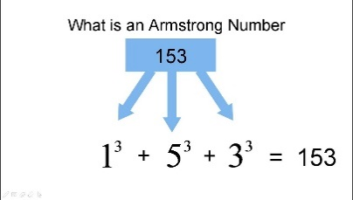g. Write a program to check whether given number is palindrome or not. (Check whether reversed number is equal to original number or not)

h. Write a program to check whether given number is Armstrong or not.

i. WAP to reverse a string and check whether a string is palindrome or not

j. WAP to count vowels and consonant in given string.